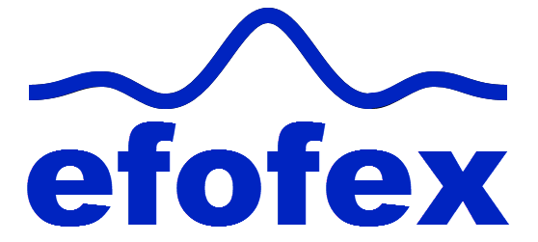
FX Library Modules

Complex Number Calculations
(Rectangular)
Age 15+

Copyright Information
If you are an Efofex subscriber and work in a school, you can copy and/or modify the FX Library materials and use them with your students. We hope that this material will help you write your tests, worksheets, exams, presentations and any other educational materials. You cannot claim copyright over the FX Library materials or present them as your own work.
FAQ

Who are the questions/materials for?
We are providing the materials for teachers in schools. If you are a teacher in a school (or similar context) you are welcome to use the questions/materials freely in just about any manner. Most other usages of our questions/materials are prohibited. In particular, you are expressly prohibited from using our materials in any context where the aim is to generate a profit.
Can I photocopy the questions/materials for use by my students?
YES.
Can I copy questions/materials and paste them into my own documents?
YES.
Do I have to include the Efofex Software copyright notice on my own documents if I have included some of your questions/materials?
NO.
Can I use your questions/materials to generate a profit?
NO.
Can I use the questions/materials on my website/PowerPoint presentation/Moodle...?
It depends. If your usage is within the context of a teacher of students at an educational institution, YES. If you want to use the materials for profit, NO.
I am a home-schooling parent. Can I use your materials?
YES.
I am a student and want to use your products for revision. Can I use them?
YES (but make sure to tell your teachers how good they are!)
Can I modify your questions/materials for my own use?
YES.
If I modify your questions, can I claim copyright?
It depends. If the modifications are substantial, YES. If the modifications are trivial or superficial, NO. Using the Parameter Regeneration feature of our products is NOT a substantial modification
I am a professional tutor. Can I use your materials with my students?
NO.
Can I republish your materials?
NO.
I think that I might be able to use your materials but don't seem to fit any of your FAQs. What do I do?
Send us an email describing what you want to do (to info@efofex.com) and we will get back to you as soon as possible.

How To Use This Material
Copy a question from this document and paste (with reparametizing) into your document. This allows you to quickly build a collection of regeneratable questions into a test, worksheet, presentation or exam.

Question
Simplify 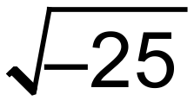
Solution
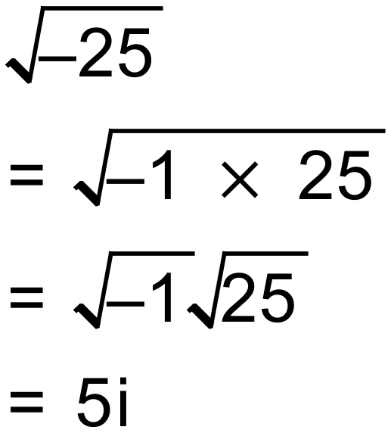
Notes
11 variations
Question
Simplify 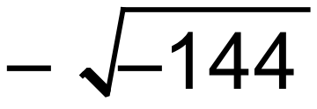
Solution
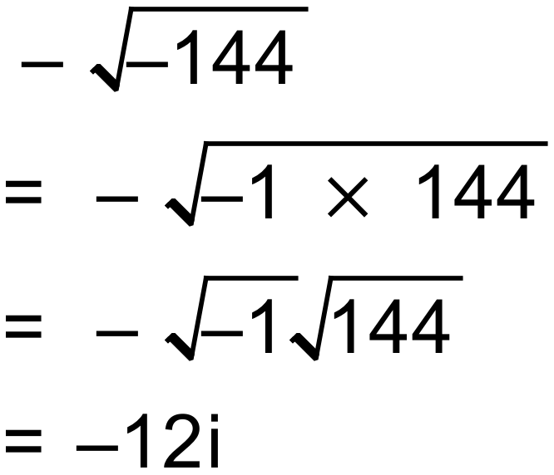
Notes
11 variations
Question
Simplify 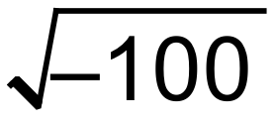
Solution
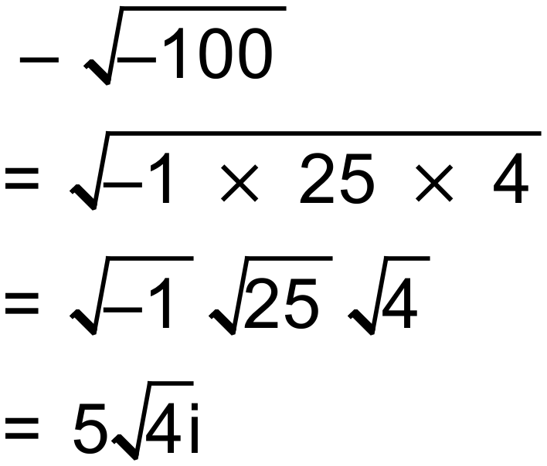
Notes
24 variations
Question
Simplify 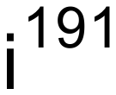
Solution
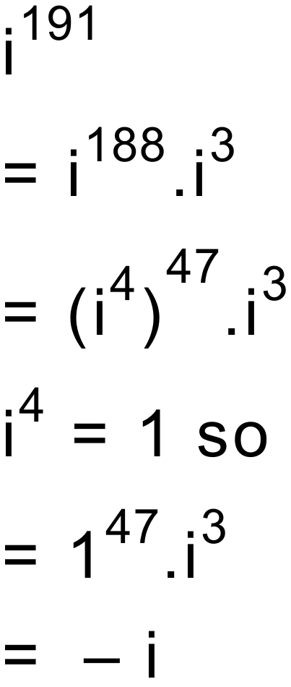
Notes
90+ variations
Question
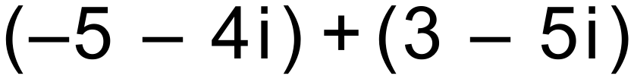
Solution
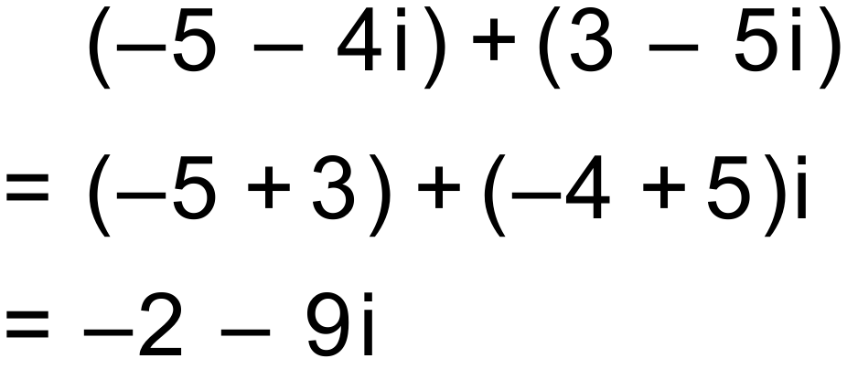
Notes
2000+ variations
Question
Solution
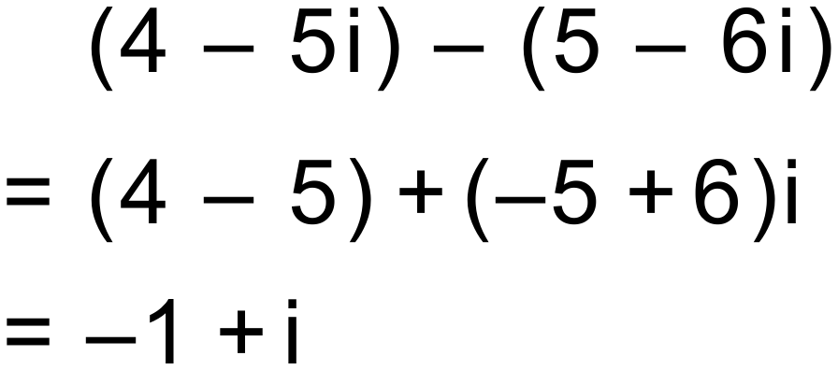
Notes
2000+ variations
Question
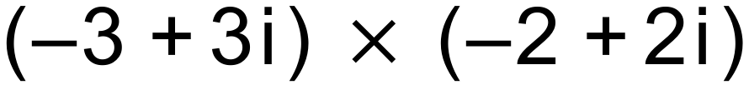
Solution
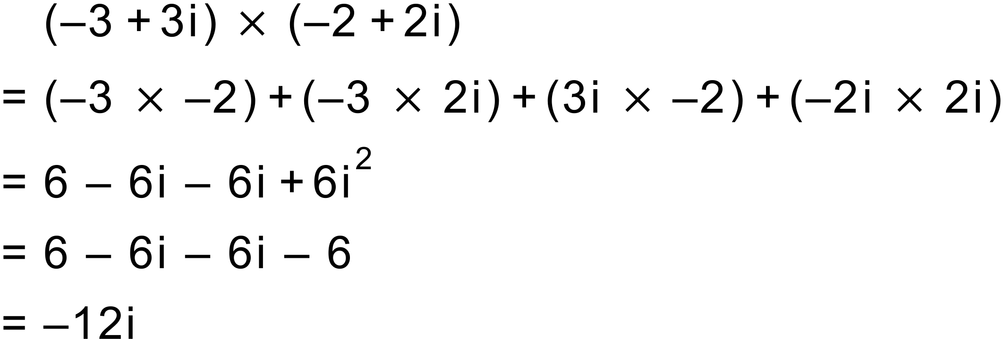
Notes
2000+ variations
Question
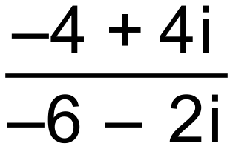
Solution
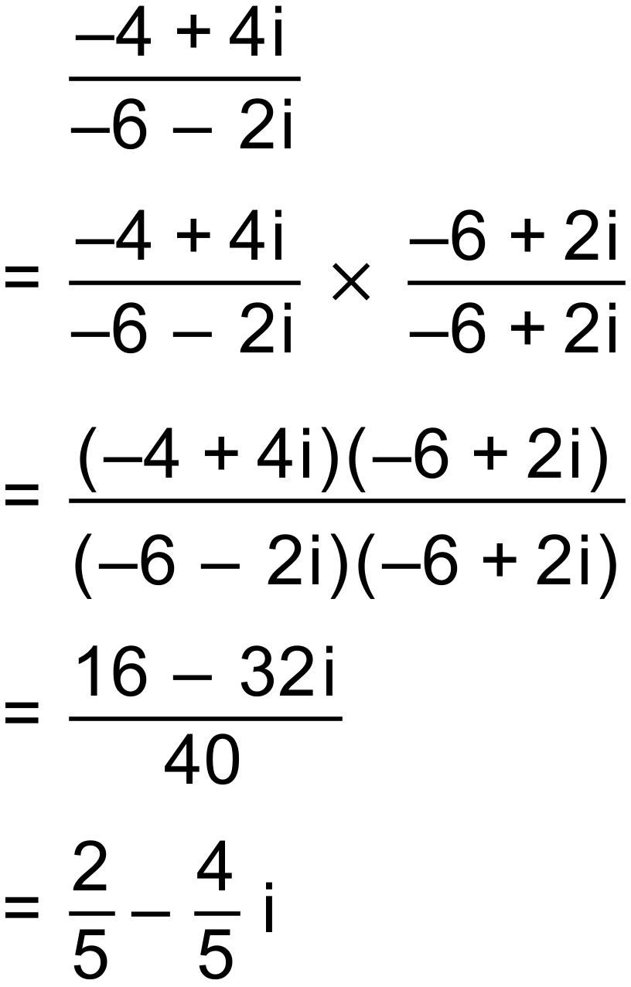
Notes
2000+ variations

Question
Simplify the following giving the final answer in the form a + bi
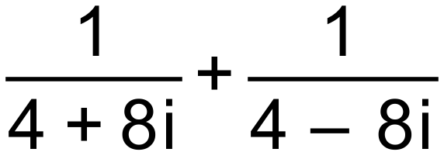
Solution
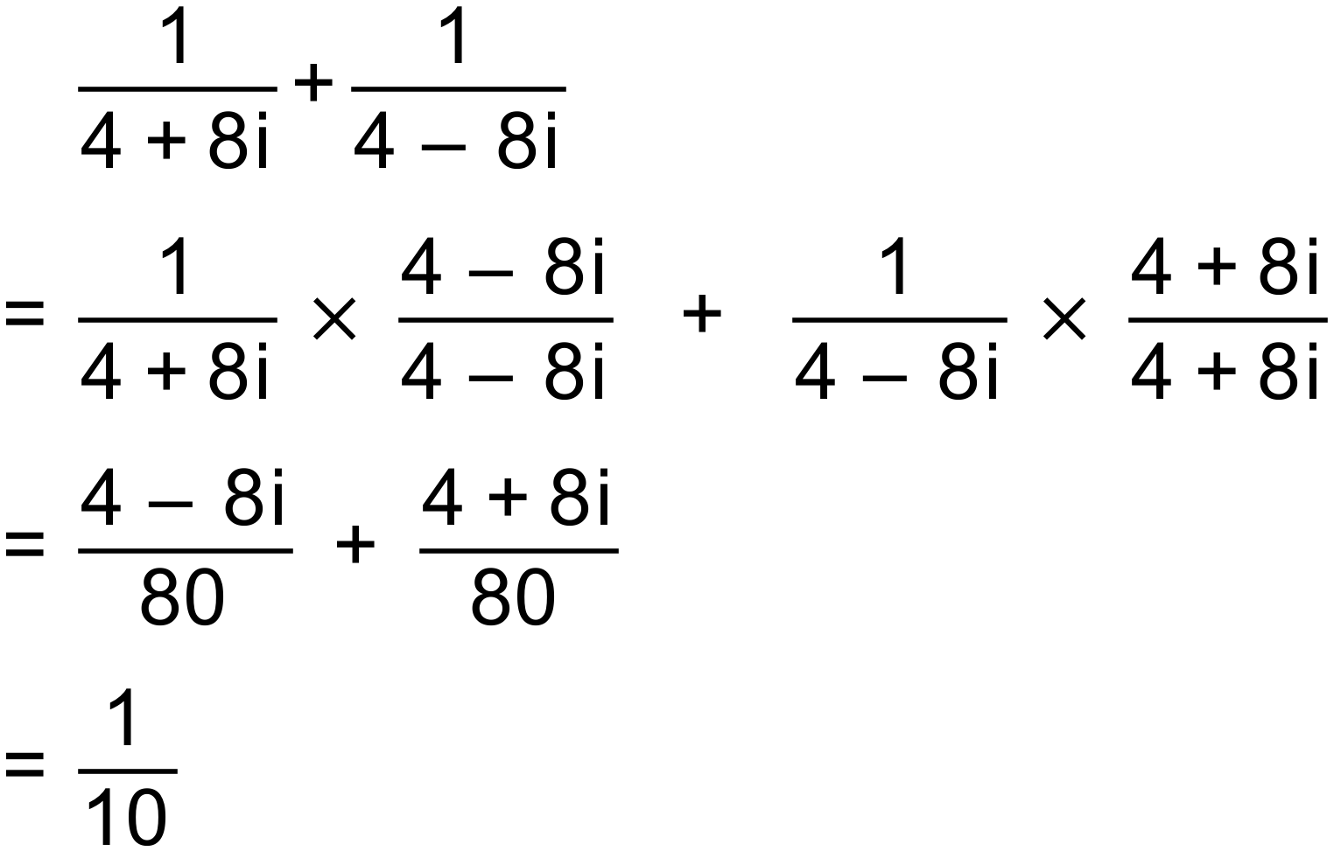
Notes
50+ variations

Question
Simplify the following giving the final answer in the form a + bi
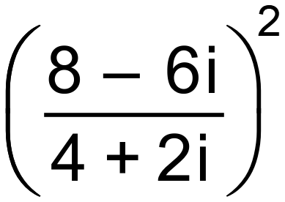
Solution
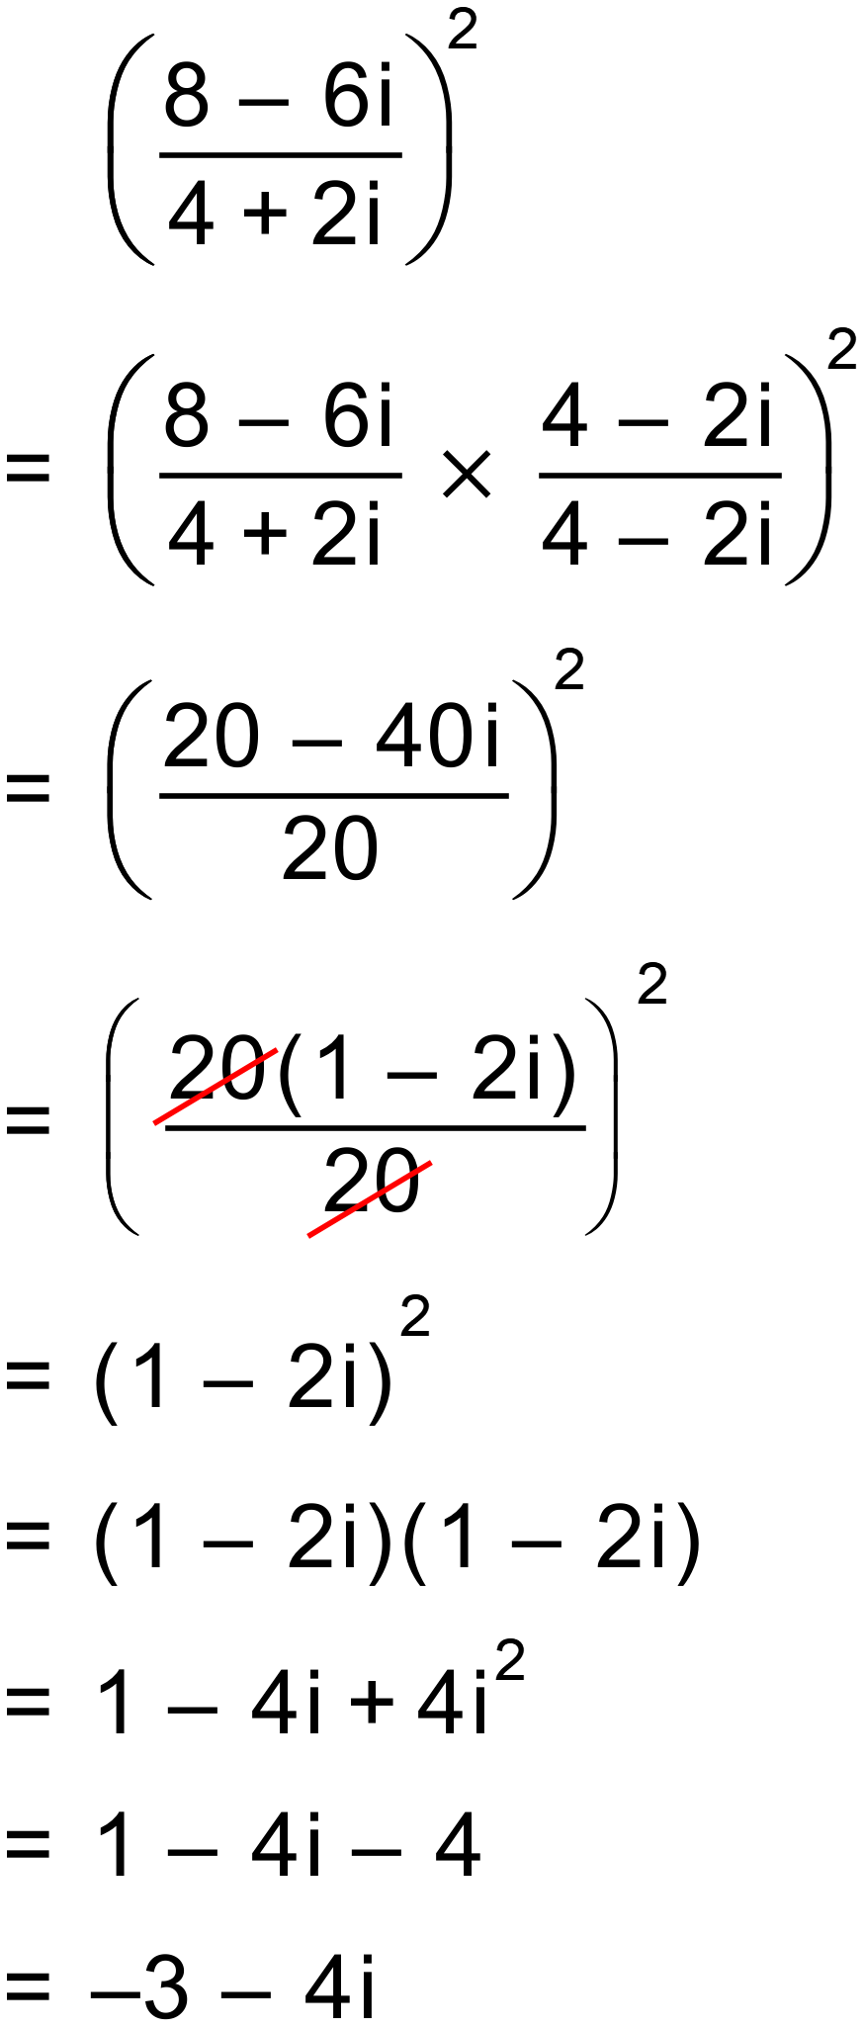
Notes
300+ variations

Question
Simplify the following giving the final answer in the form a + bi
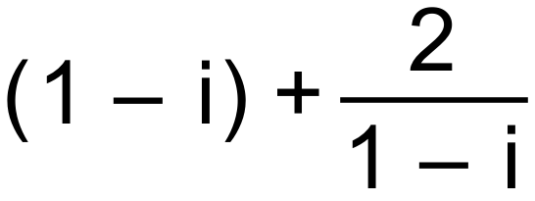
Solution
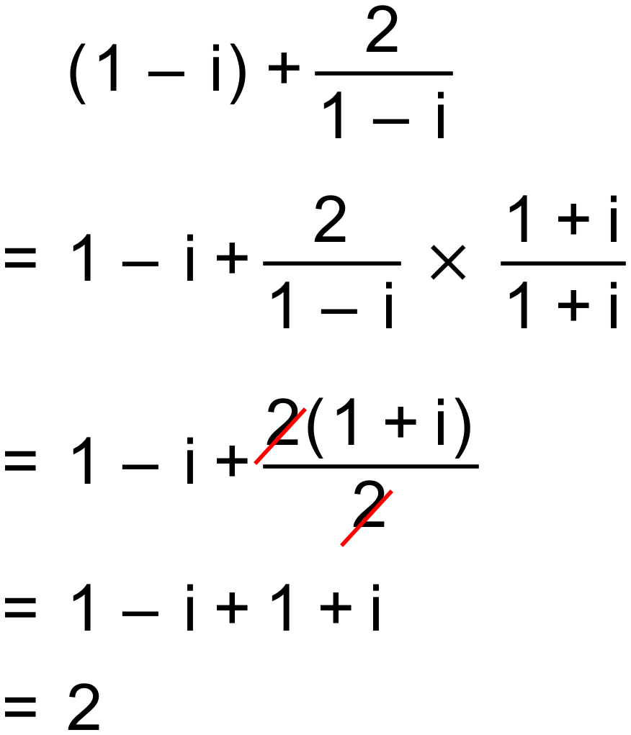
Notes
150+ variations

Question
Simplify the following giving the final answer in the form a + bi
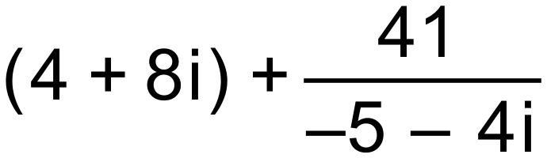
Solution
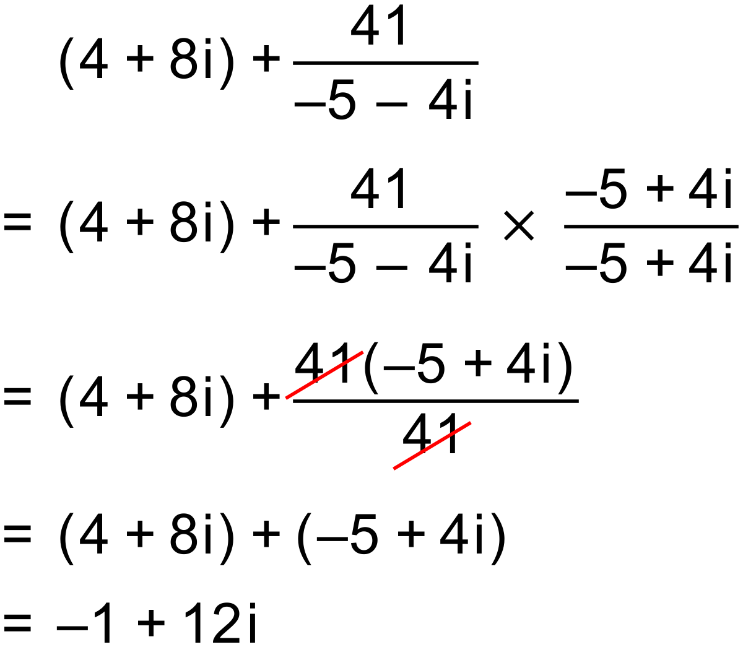
Notes
300+ variations
Question
Find the value of x and the value of y in the following equation (x and y are both reals).

Solution
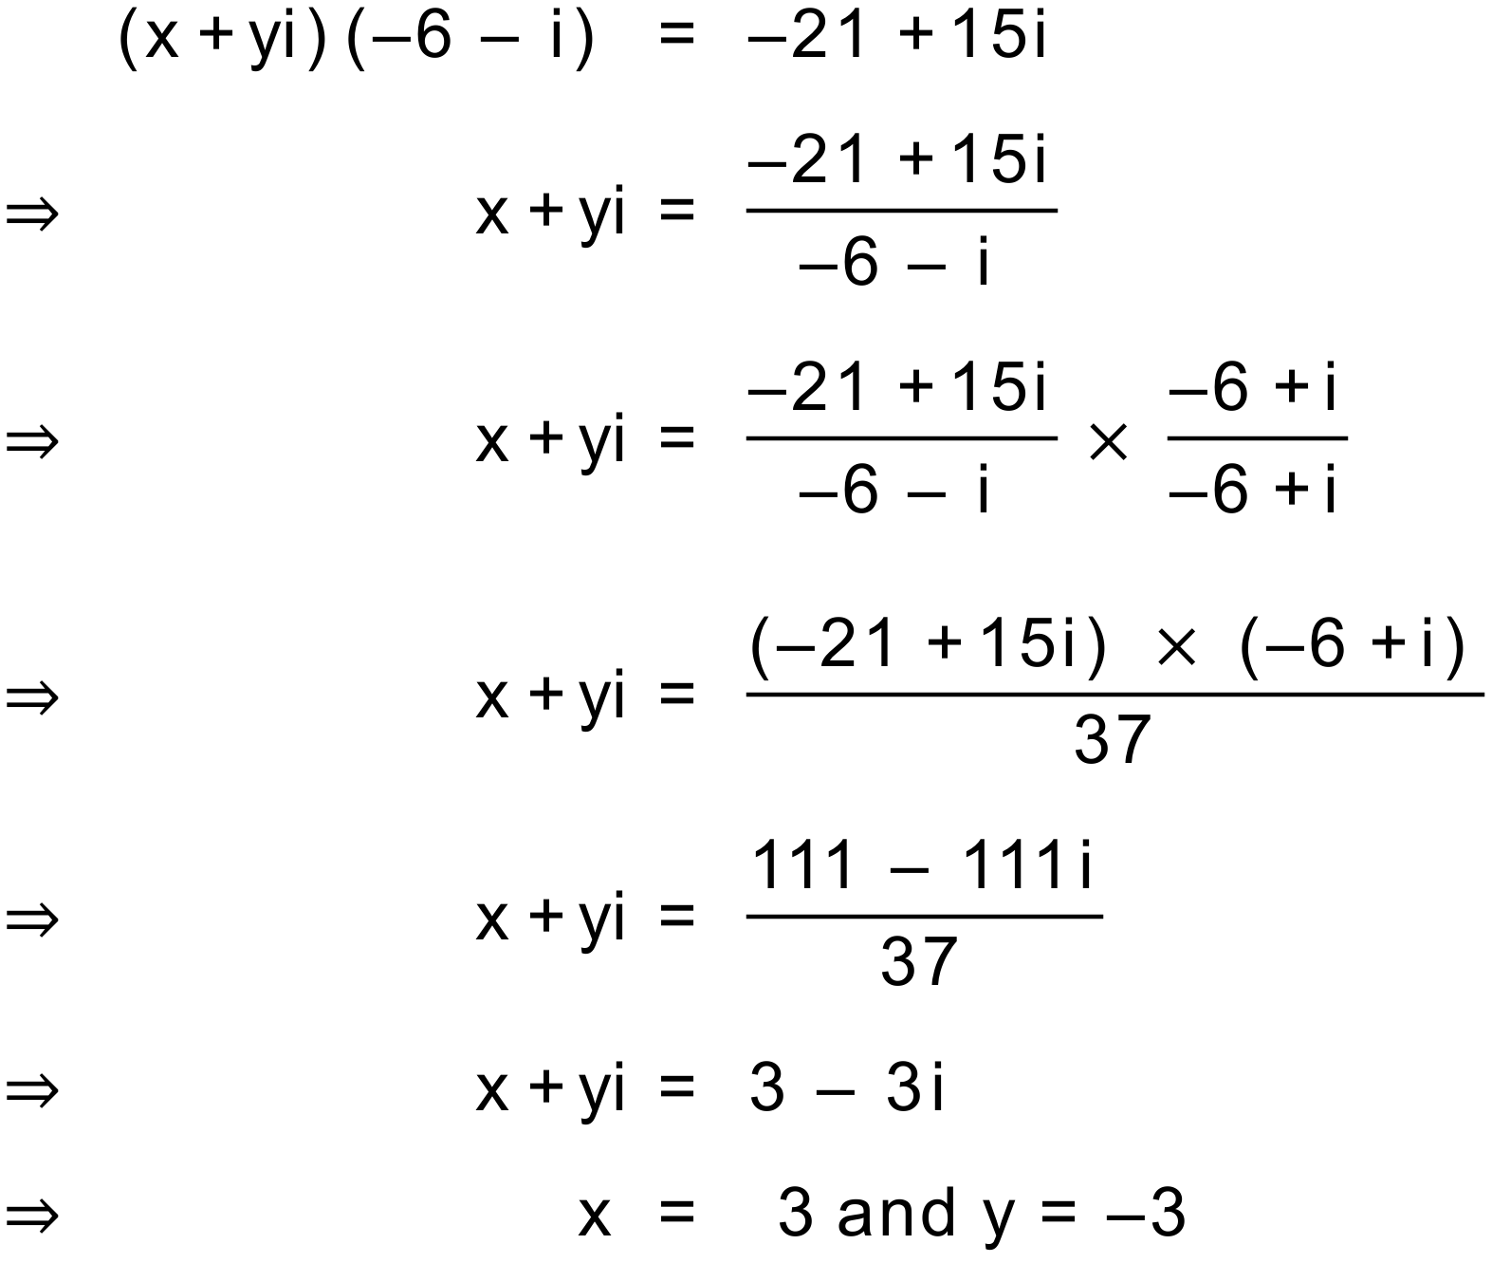 OR 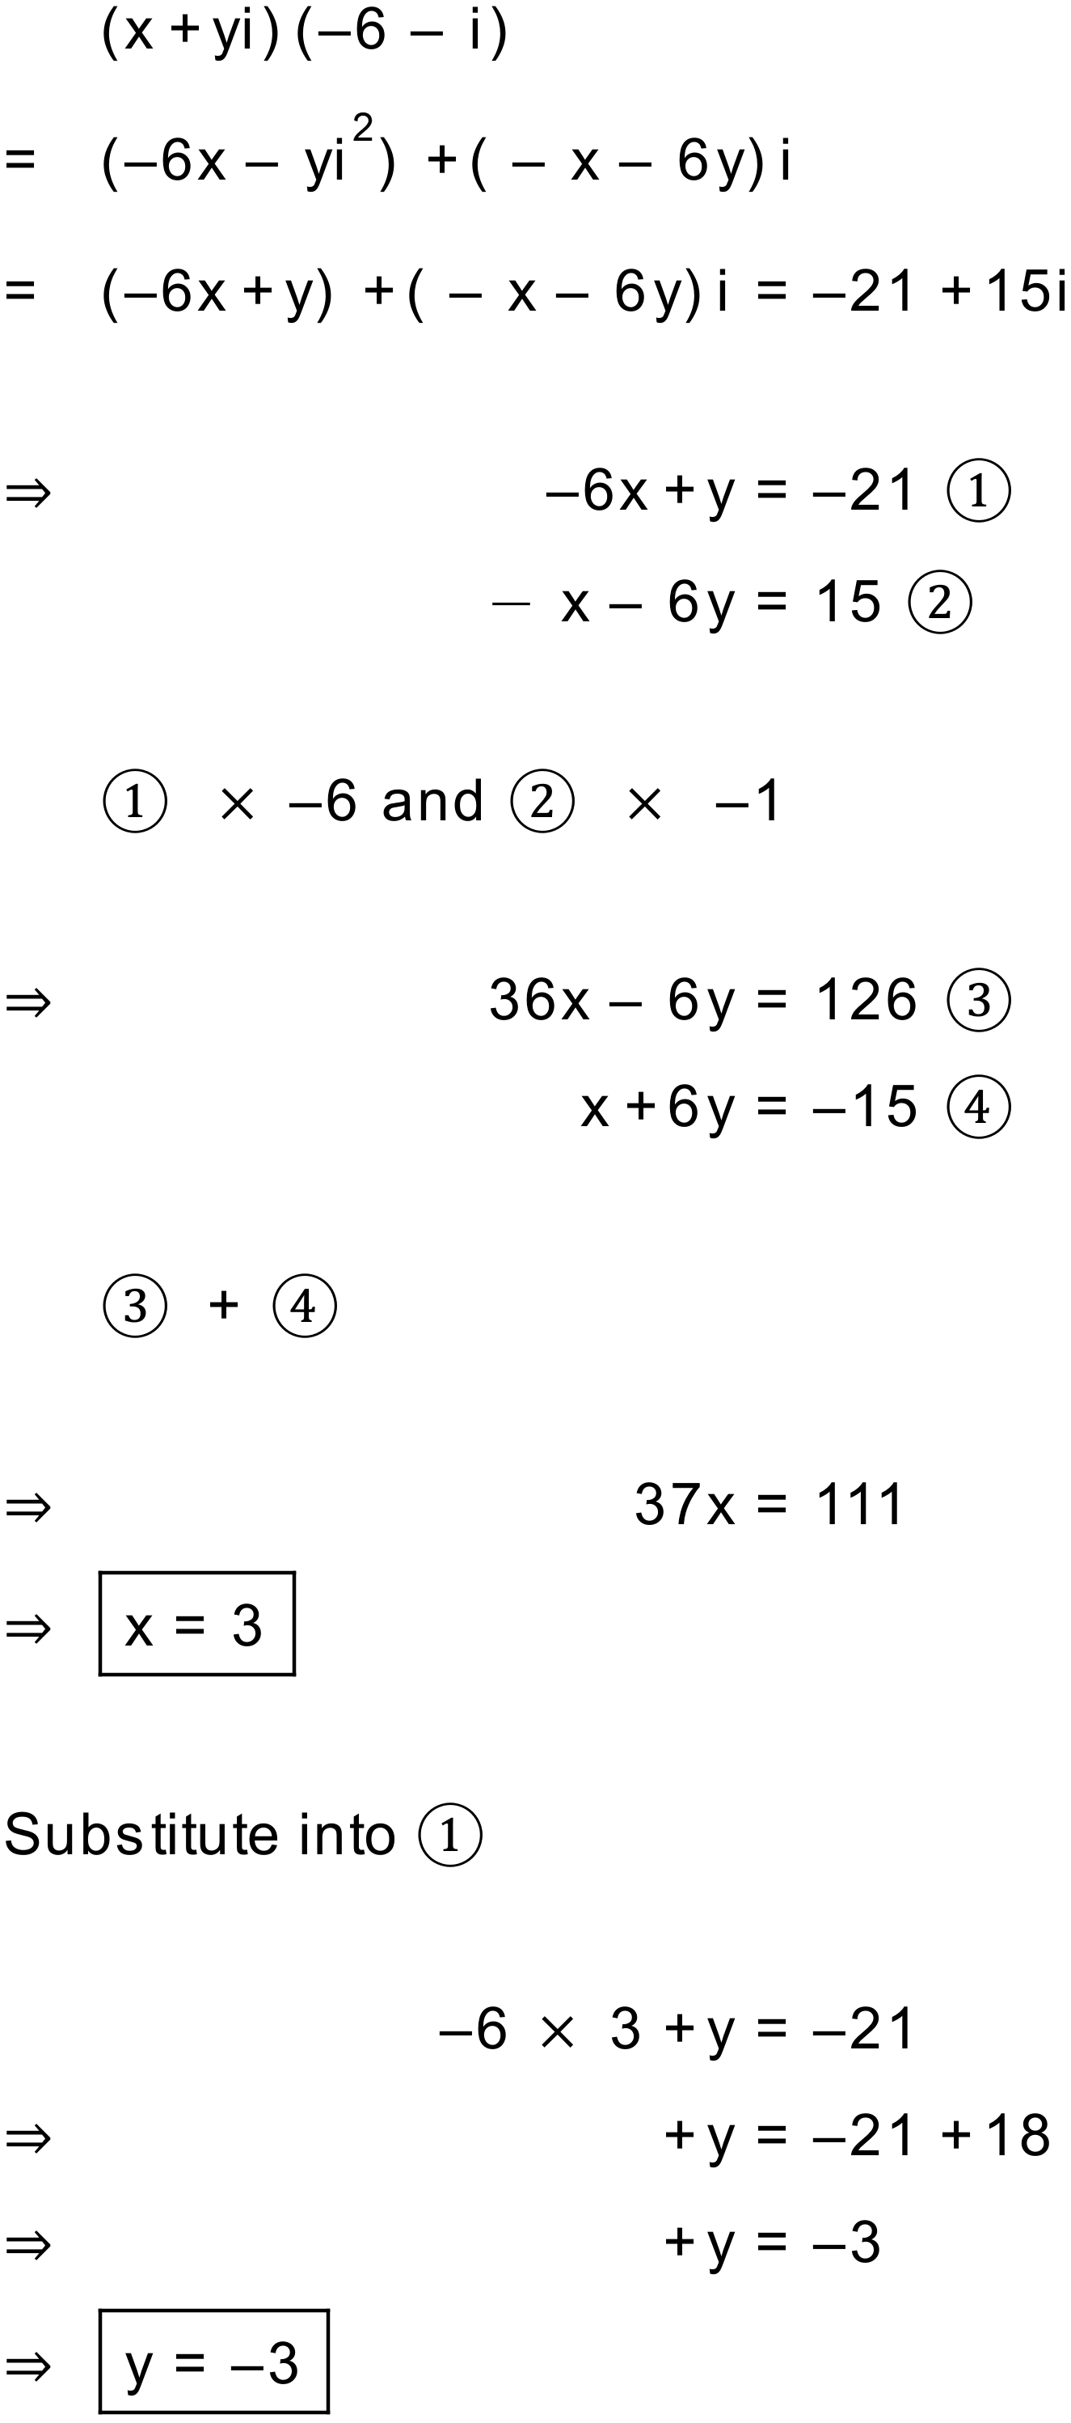
Notes
3000+ variations

Question
Find the value of x and the value of y in the following equation (x and y are both reals).
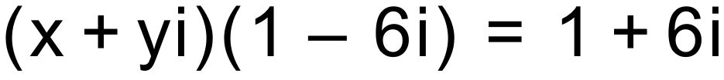

Solution
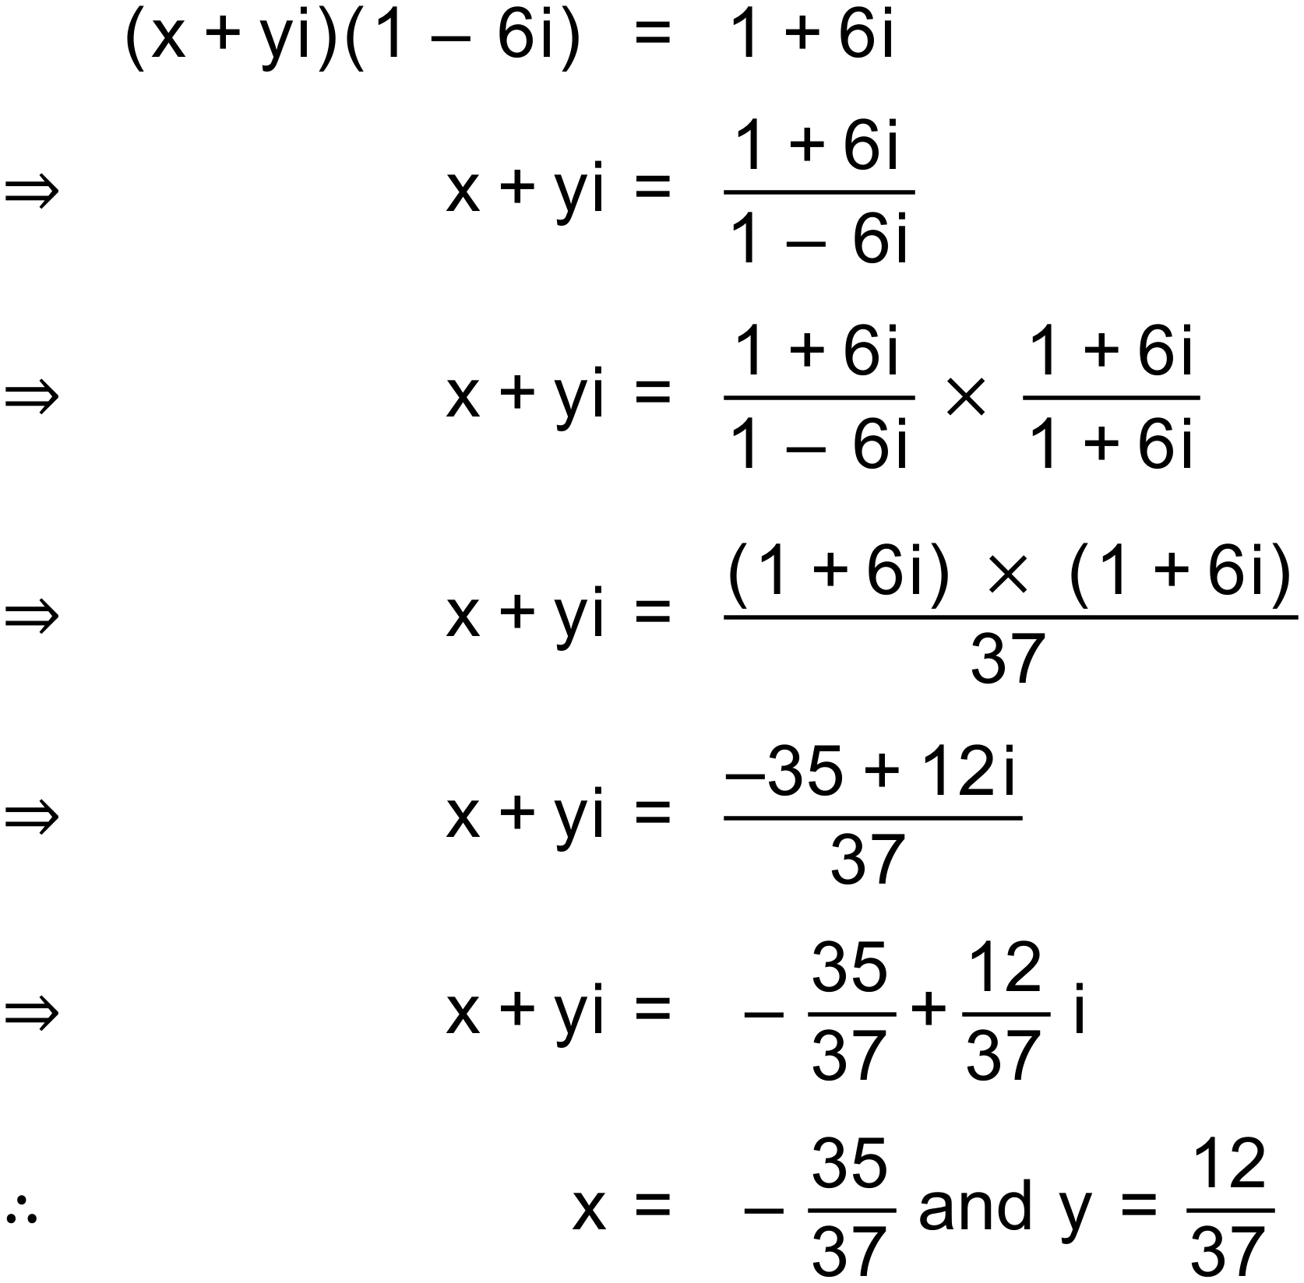
Notes
150+ variations

