FX Library Modules

Bearings

Copyright Information
If you are an Efofex subscriber and work in a school, you can copy and/or modify the FX Library materials and use them with your students. We hope that this material will help you write your tests, worksheets, exams, presentations and any other educational materials. You cannot claim copyright over the FX Library materials or present them as your own work.
FAQ

Who are the questions/materials for?
We are providing the materials for teachers in schools. If you are a teacher in a school (or similar context) you are welcome to use the questions/materials freely in just about any manner. Most other usages of our questions/materials are prohibited. In particular, you are expressly prohibited from using our materials in any context where the aim is to generate a profit.
Can I photocopy the questions/materials for use by my students?
YES.
Can I copy questions/materials and paste them into my own documents?
YES.
Do I have to include the Efofex Software copyright notice on my own documents if I have included some of your questions/materials?
NO.
Can I use your questions/materials to generate a profit?
NO.
Can I use the questions/materials on my website/PowerPoint presentation/Moodle...?
It depends. If your usage is within the context of a teacher of students at an educational institution, YES. If you want to use the materials for profit, NO.
I am a home-schooling parent. Can I use your materials?
YES.
I am a student and want to use your products for revision. Can I use them?
YES (but make sure to tell your teachers how good they are!)
Can I modify your questions/materials for my own use?
YES.
If I modify your questions, can I claim copyright?
It depends. If the modifications are substantial, YES. If the modifications are trivial or superficial, NO. Using the Parameter Regeneration feature of our products is NOT a substantial modification
I am a professional tutor. Can I use your materials with my students?
NO.
Can I republish your materials?
NO.
I think that I might be able to use your materials but don't seem to fit any of your FAQs. What do I do?
Send us an email describing what you want to do (to info@efofex.com) and we will get back to you as soon as possible.

How To Use This Material
Copy a question from this document and paste (with reparametizing) into your document. This allows you to quickly build a collection of regeneratable questions into a test, worksheet, presentation, or exam.

Question
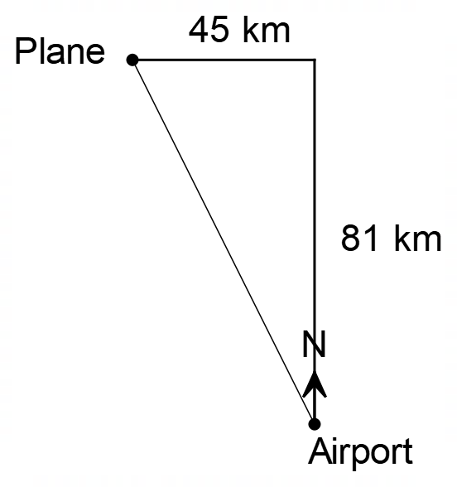
A plane is 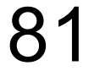 km North and 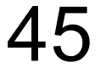 km West of an airport. The pilot wishes to fly directly to the airport.
- How far from the airport is plane?
- What bearing should the pilot fly on to fly directly to the airport?

Solution
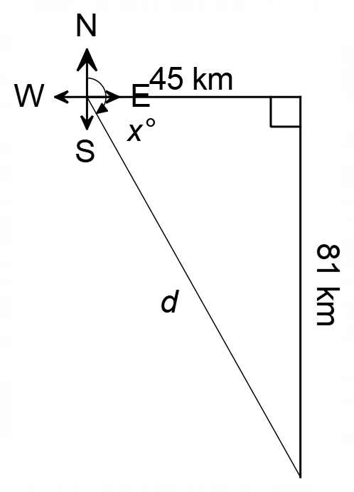

a) 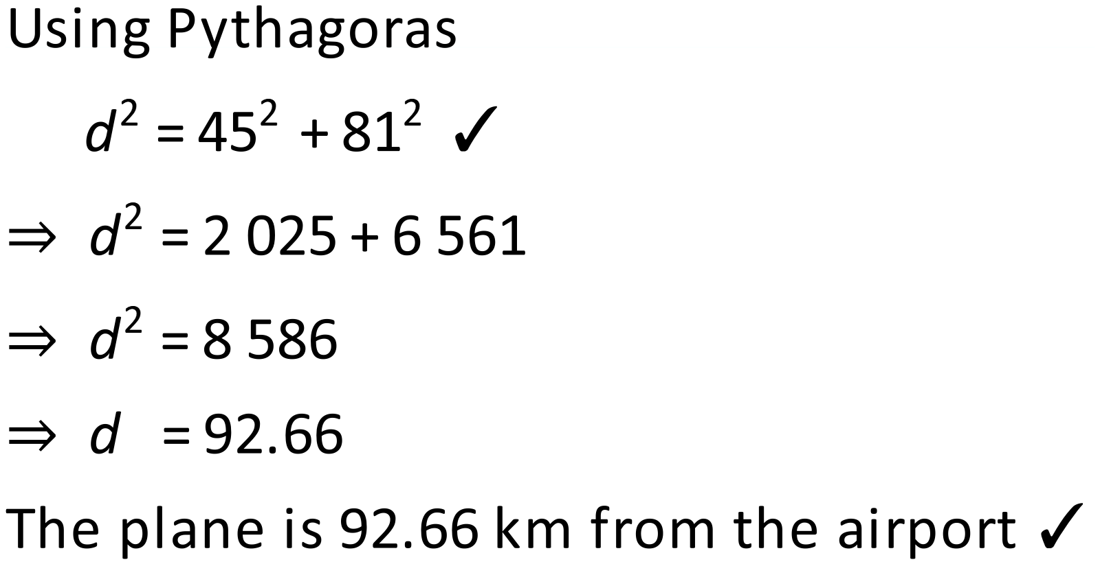
b) 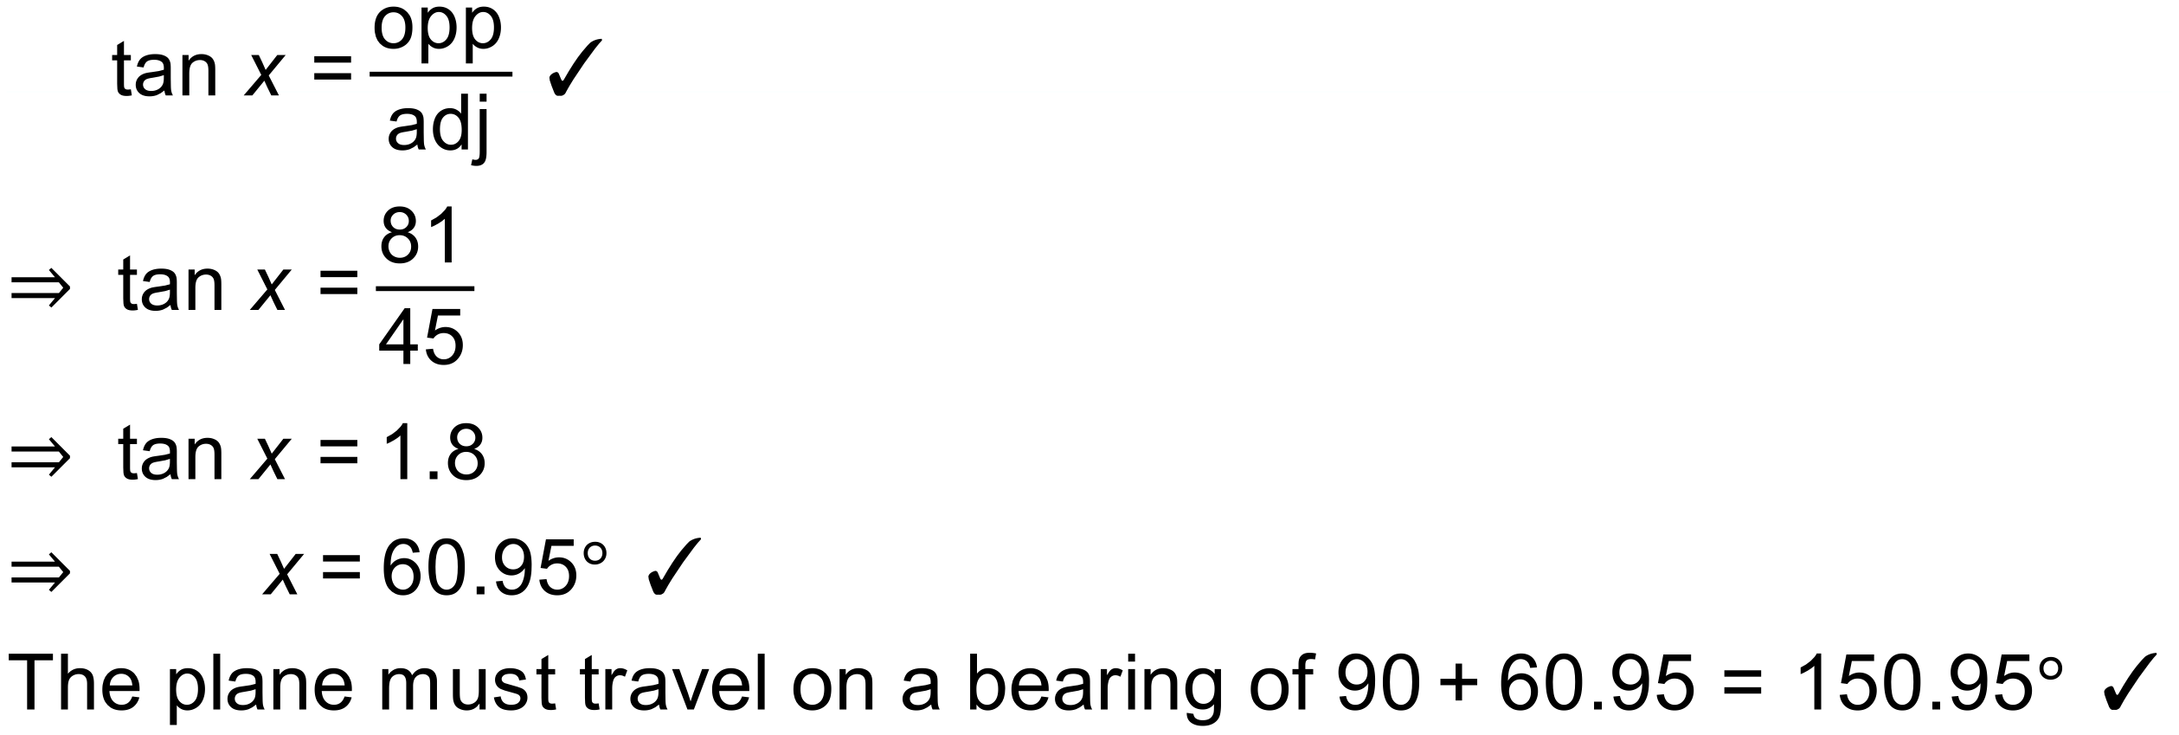
Notes
6000+ variations.
Question
In each of these examples, find the bearing of A from B
a)
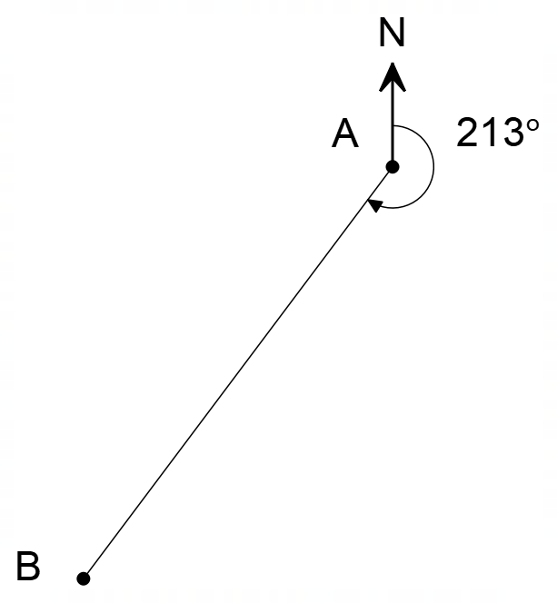

b)
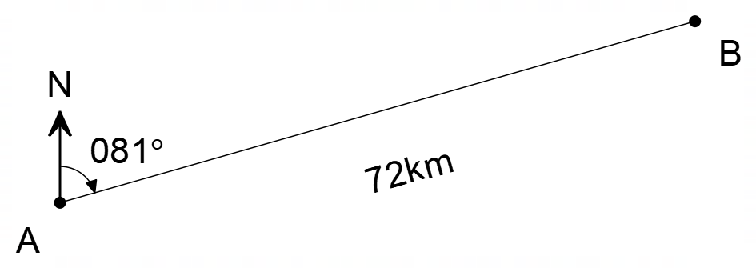

c)
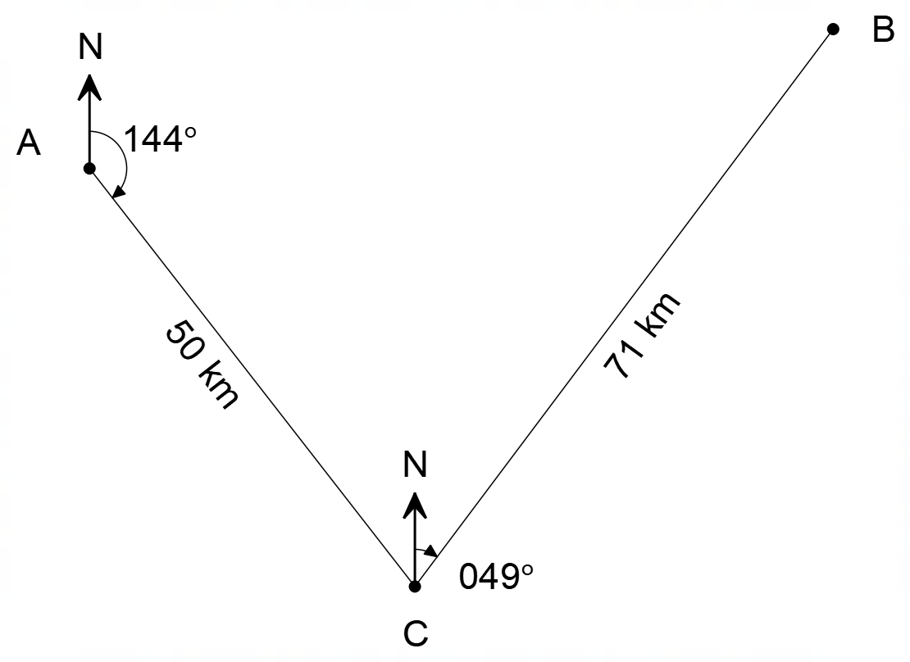

Solution
a)
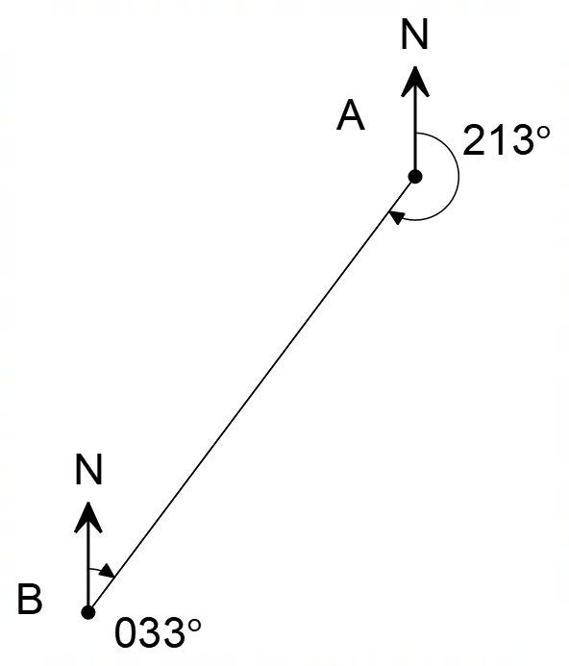

b)
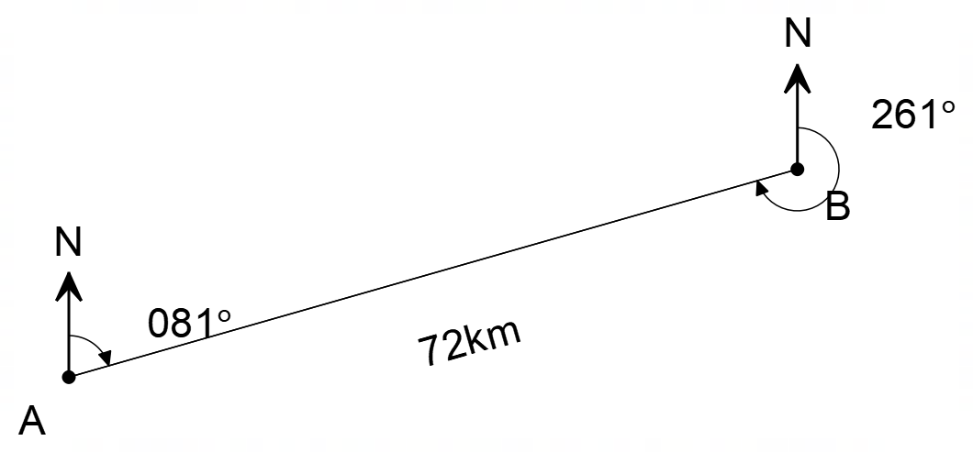

c)
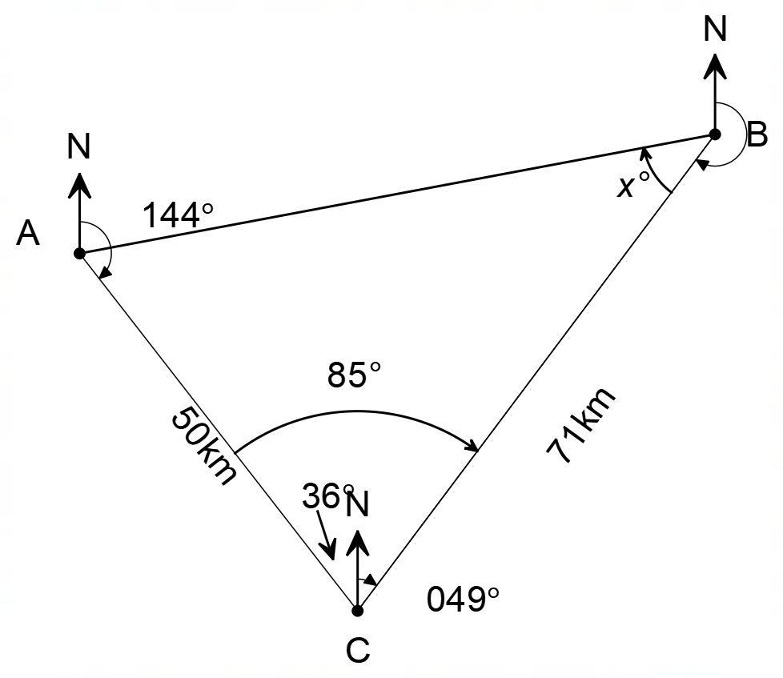
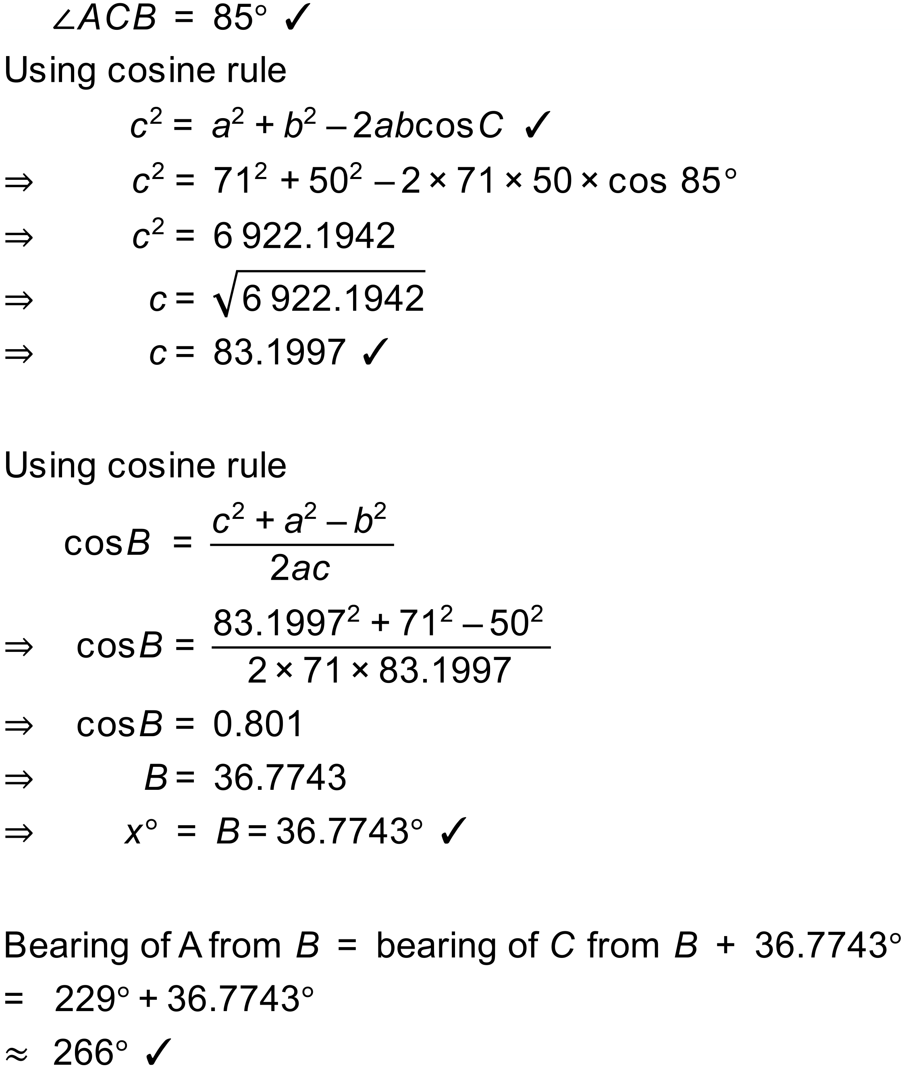

Notes
10000+ variations.

Question
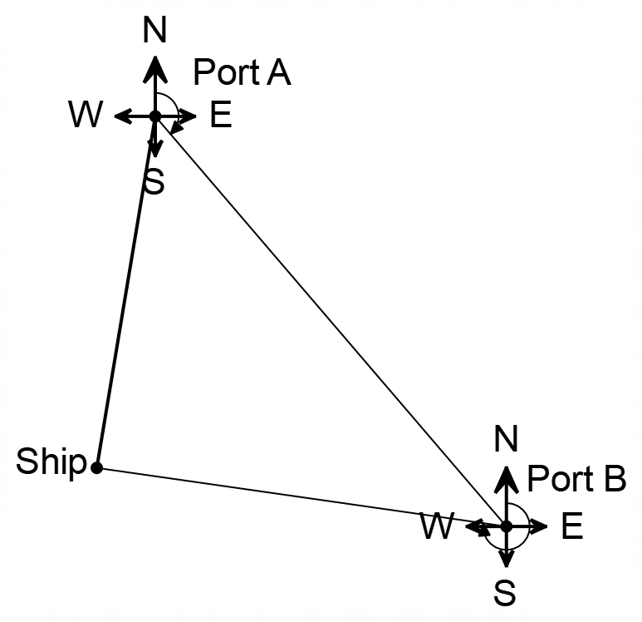
A ship leaves from Port A at 1pm and travels on a bearing of 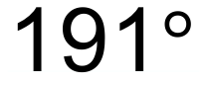 at a constant 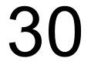km/h. At 9pm, the ship’s engine suffers a major malfunction and from that time can only maintain a speed of km/h.
The ship needs to be repaired urgently and the ship’s captain must decide whether to turn back to Port A or proceed on to Port B that is 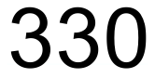km, on a bearing of 148°, from Port A.

- How far will the ship be away from Port A at 9pm?
- If the captain decides to return to Port A, on what bearing must the ship travel?
- The captain has calculated that Port B is closer to the ship than Port A and decides to proceed to Port B. On what bearing must the ship travel?
- To the nearest minute, how much time will the captain save by sailing to Port B for repairs?
[1,1,7,3 = 12 Marks]

Solution
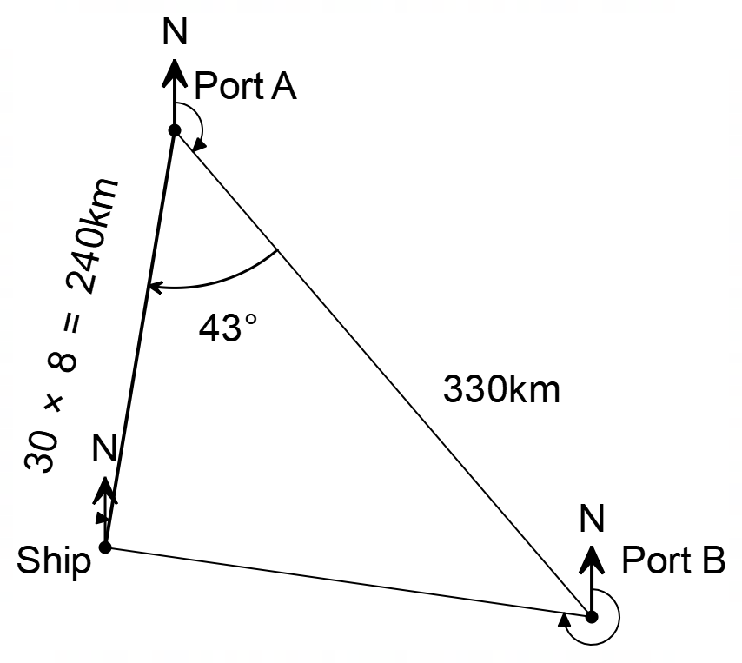

a)
The ship will be 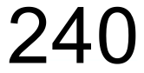 km from Port A at 9pm

b) The ship must travel on a bearing of 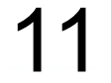° to return to Port A
c) 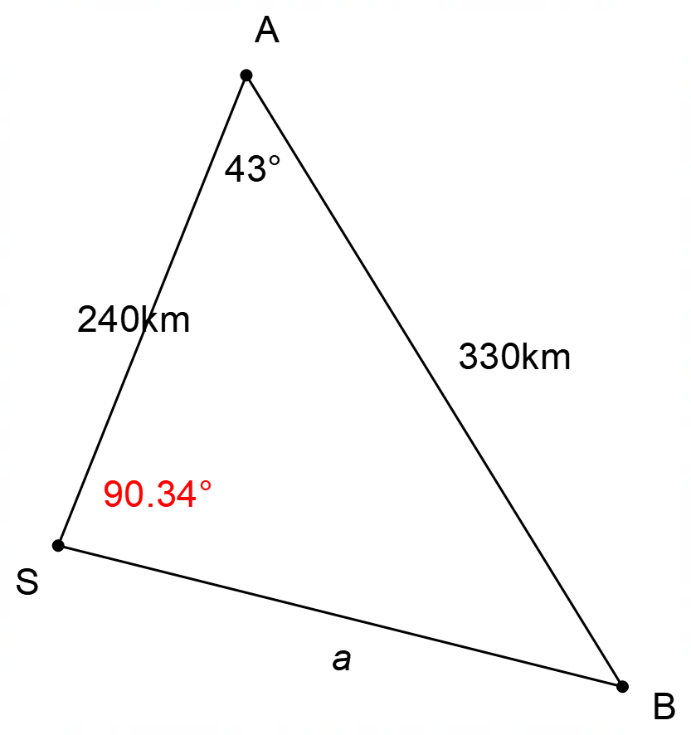

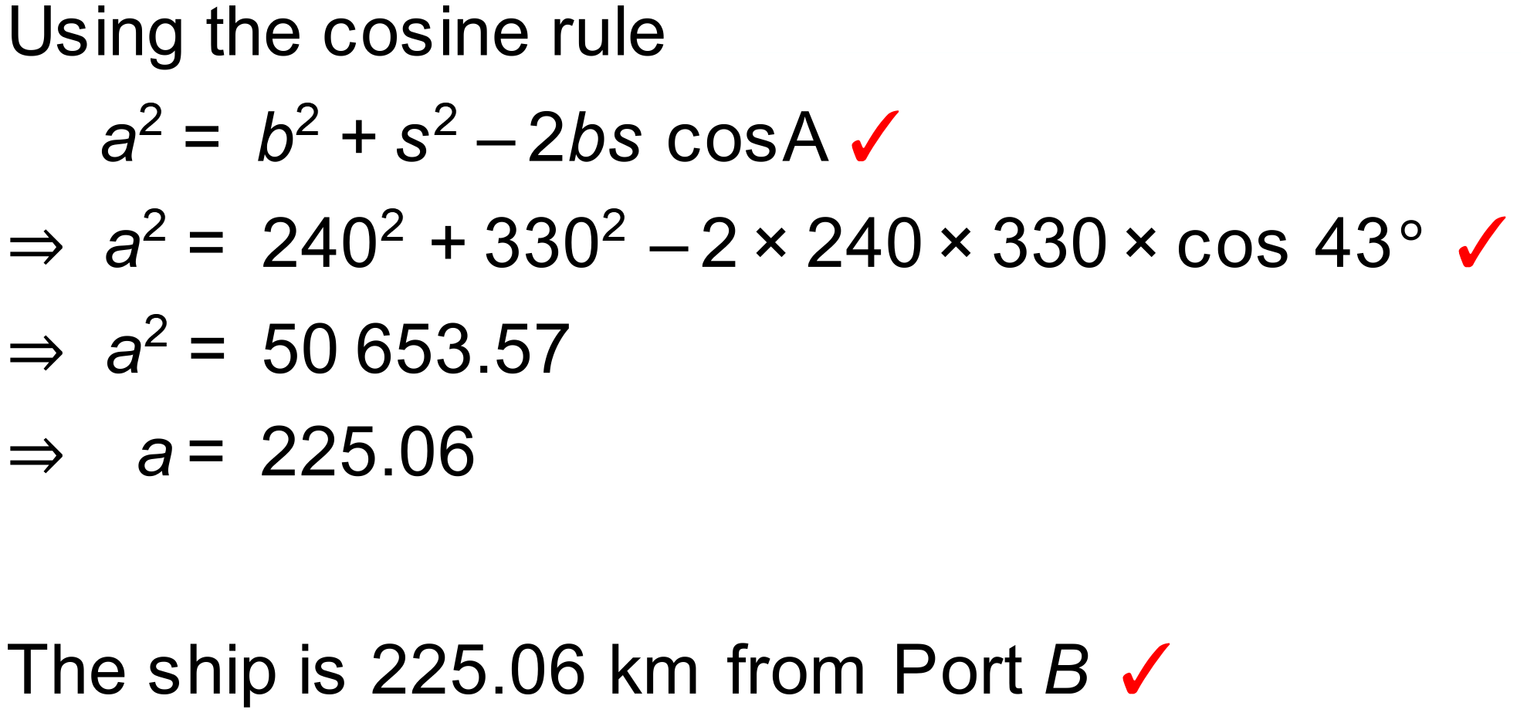
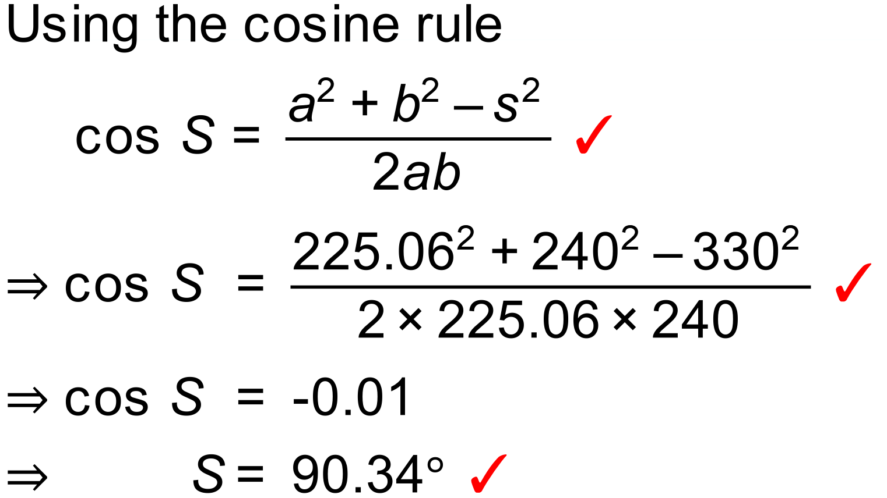
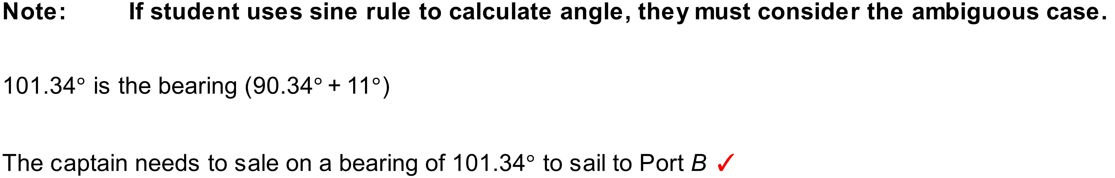d) 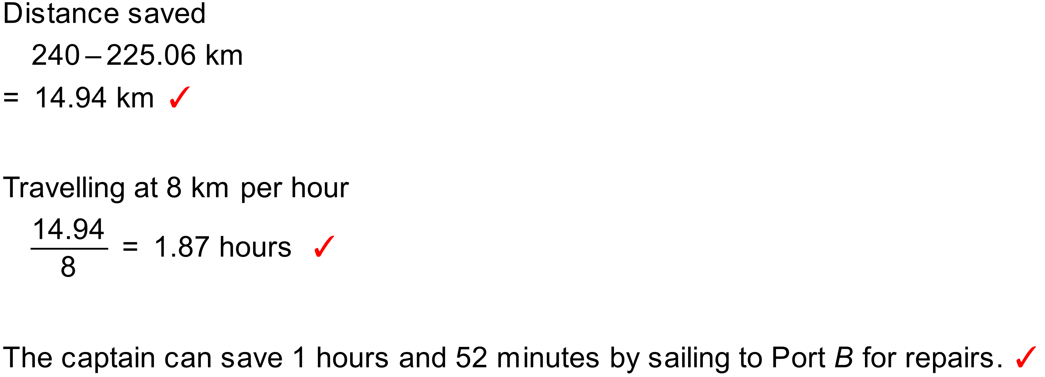

Notes
770 variations.

Question
Fire control officers have two fire observation towers in a forest that are used to detect forest fires. Tower B is km North West of Tower A. On a hot summer’s day, the two towers observe a forest fire. Tower A reports that the fire is on a bearing of 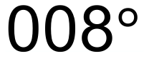 and Tower B reports that the fire is on a bearing of 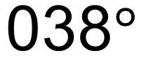.

a) Draw a diagram to represent this situation.

b) How far is the fire from Tower A?

[2,4 = 6 Marks]

Solution
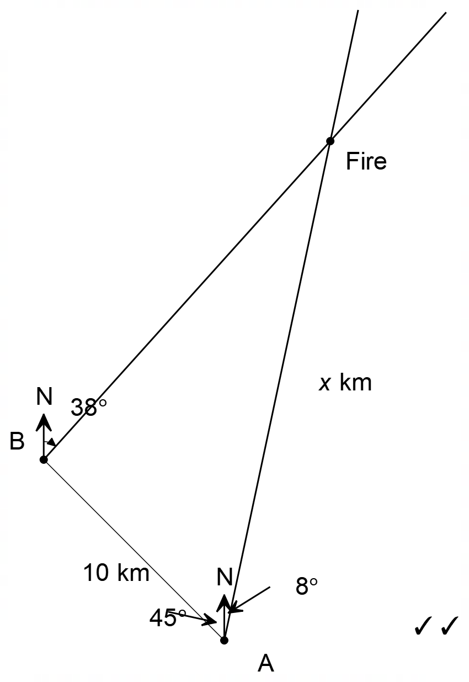
a)
b) 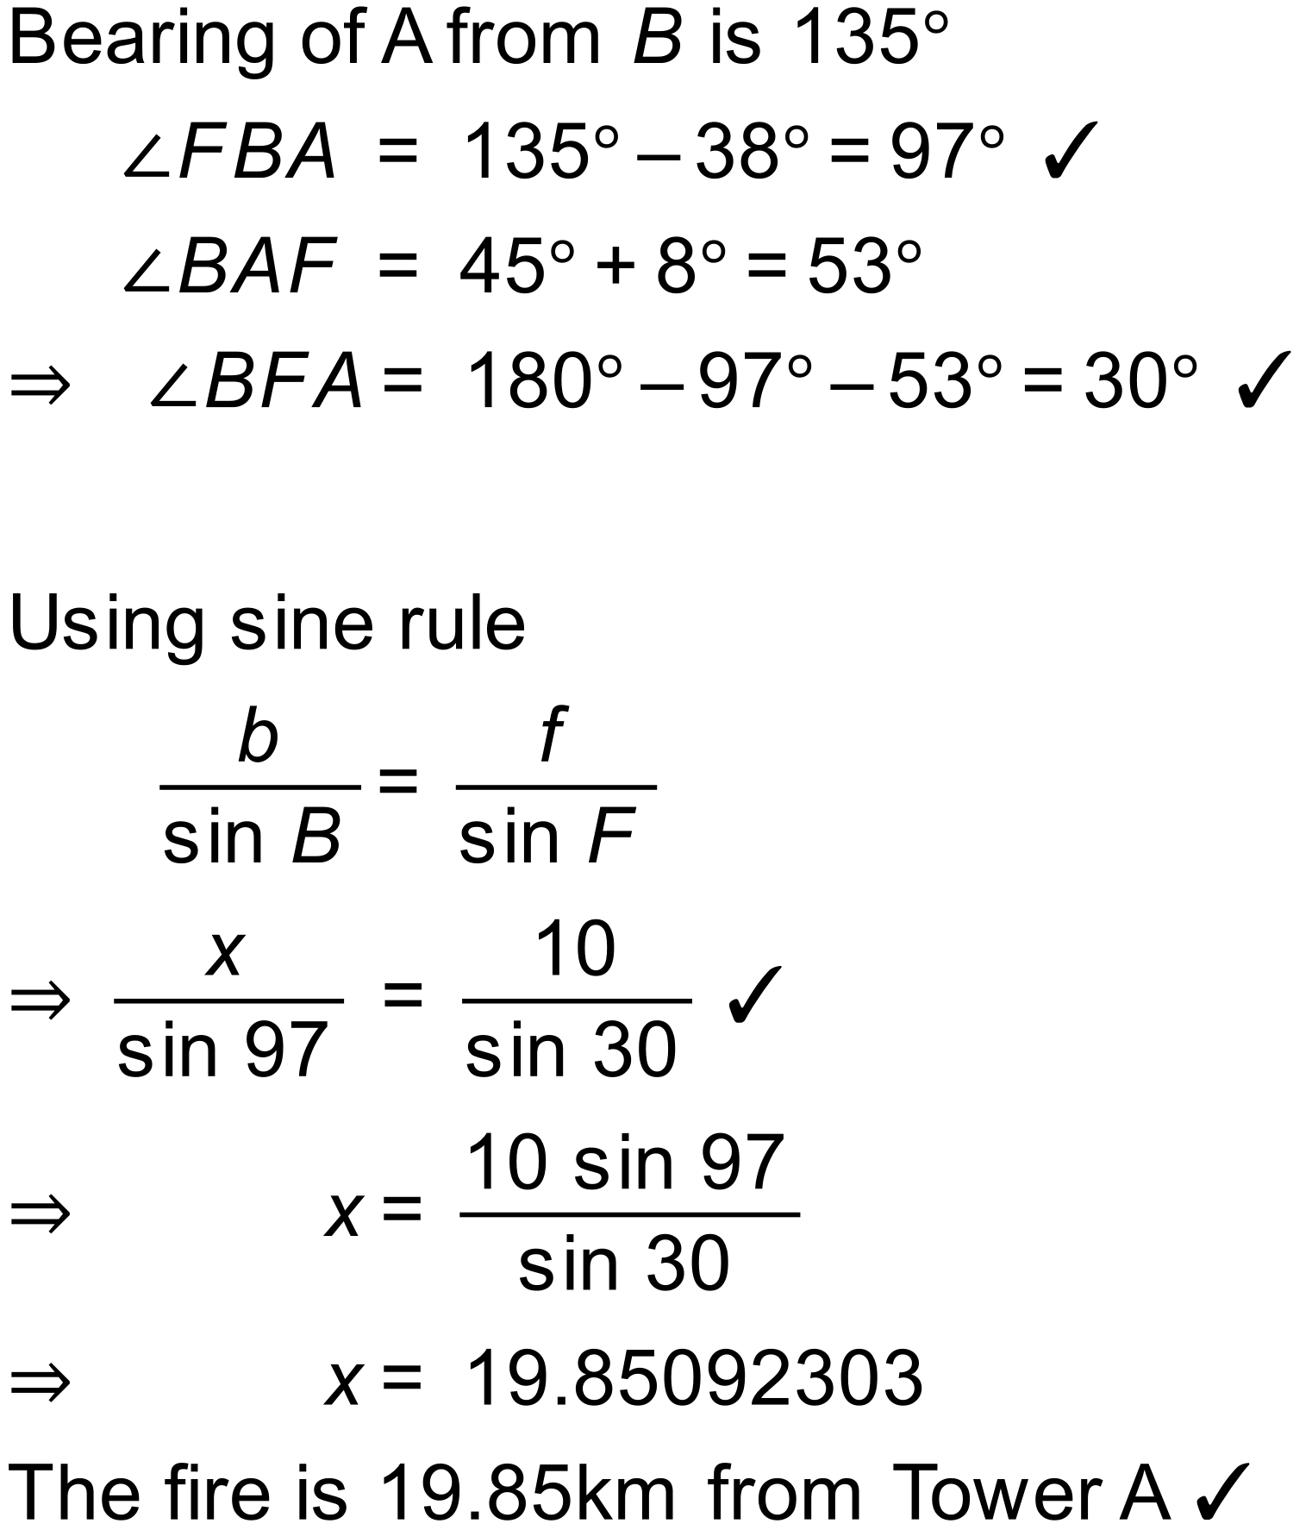

Notes
1408 variations.

Question
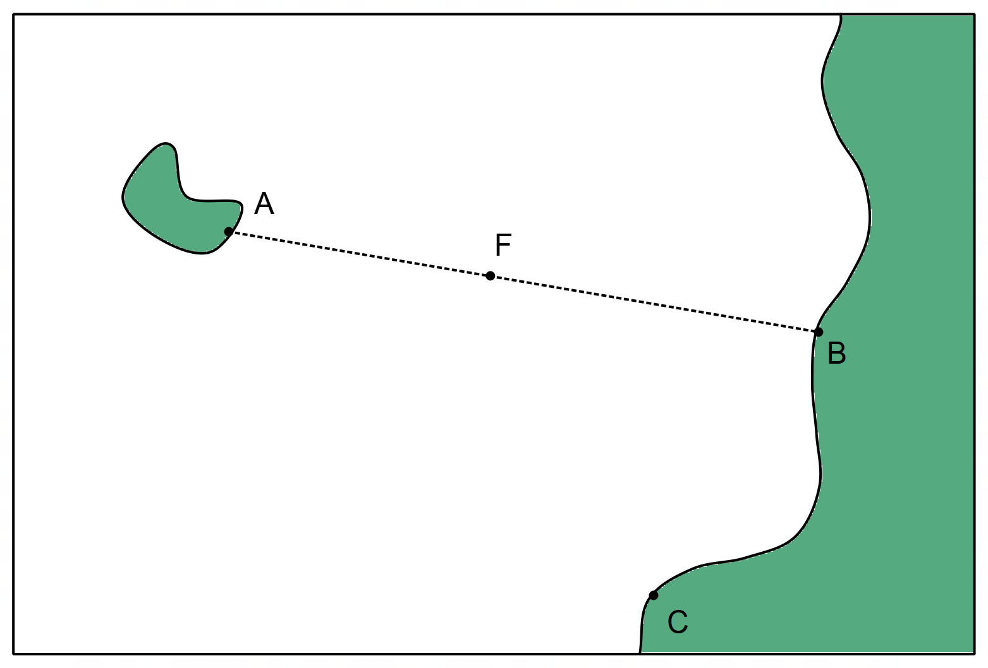
A sea rescue volunteer at point A notices a distress flare from a boat and notes that the distress flare(F) is exactly in line with point B, on a bearing of 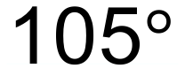. At the same moment, a second volunteer at point C sees the same distress flare on a bearing of 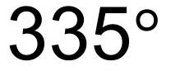. If the distance between B and C is and B is on a bearing of 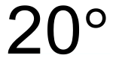 from C:
- Calculate the distance from the flare to point B (BF).
The volunteer decides to send a rescue boat to investigate the flare. They have two rescue craft available at points B and C. These rescue craft can travel at the same speed.
- Which rescue craft will arrive at point F the quickest?
The volunteer realises that it is possible that the flare might be closest to point A but quickly find that they do not have enough information available to calculate the distance AF.
- What other measurement could the volunteer make in order to calculate the distance AF?

Solution
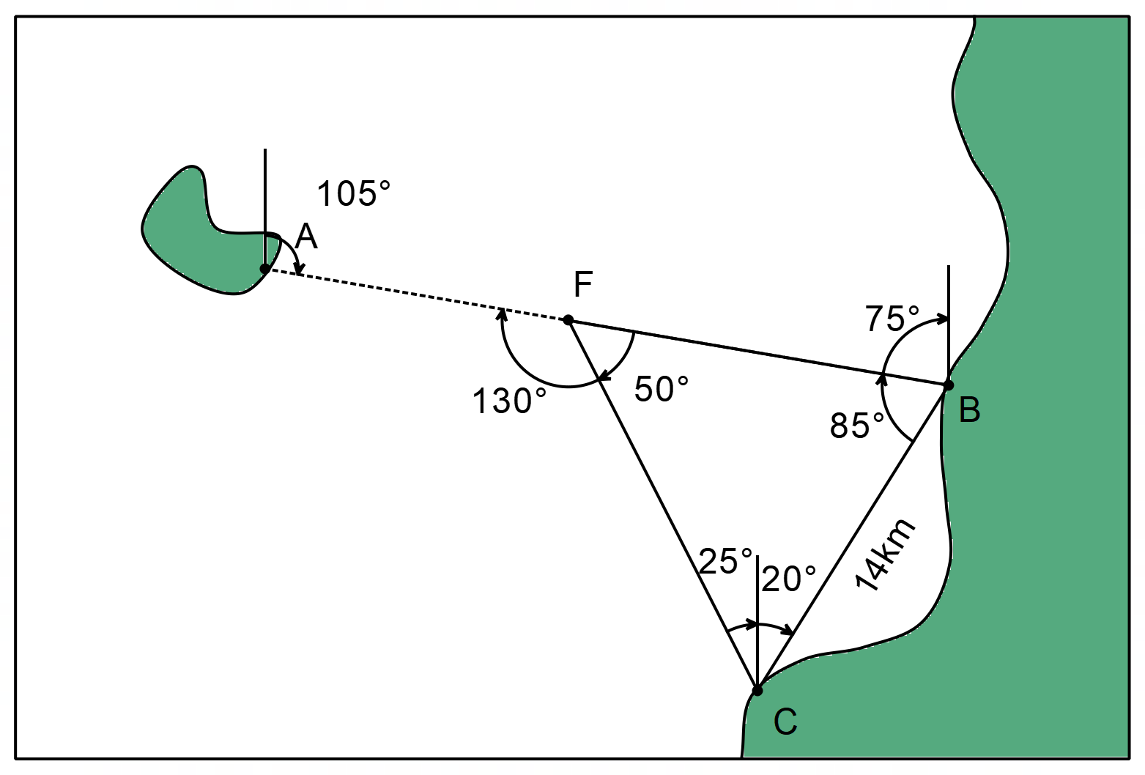

a) 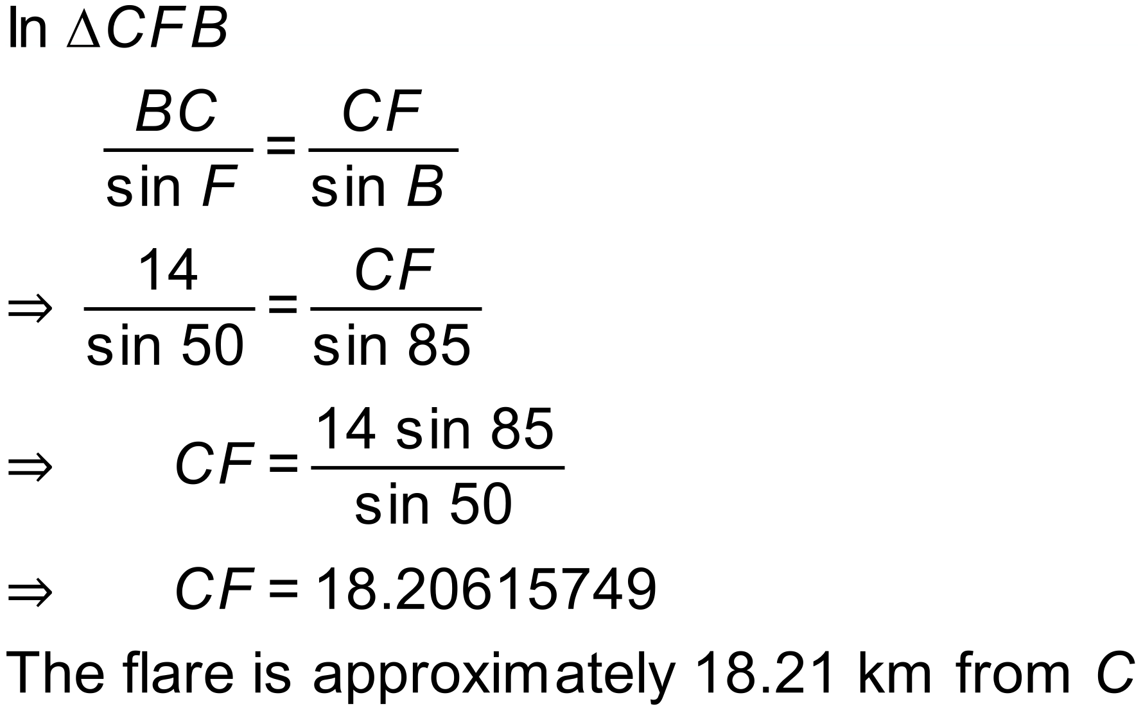

b) 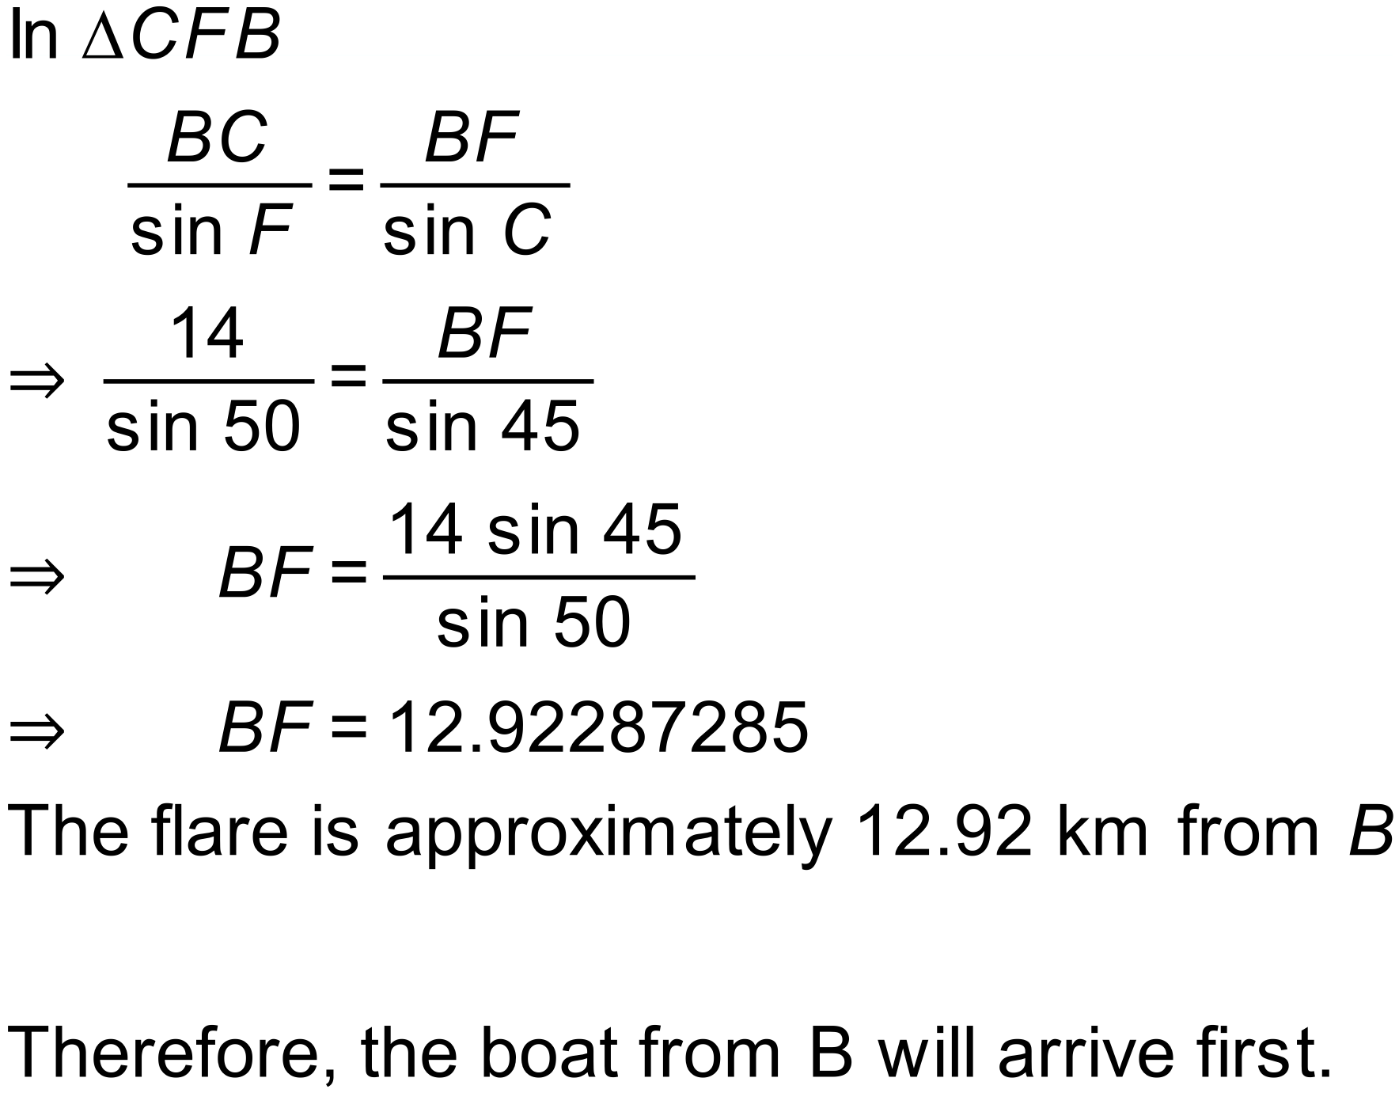

c) There are numerous extra measurements that can be taken to allow the distance from A to F to be calculated. The bearing from A to C; the bearing from C to A; the distance from A to C or the distance from A to B. Any of these is acceptable.
Notes
1680 variations.

