Area Formulae
Square
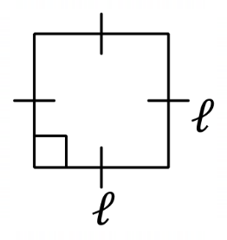 | 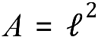 | Area = the length of the side squared
Rectangle
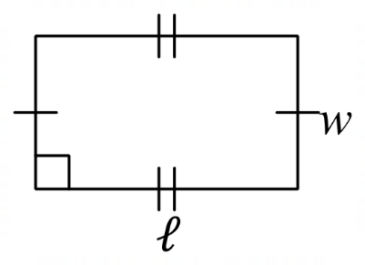 | 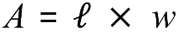 | Area = length multiplied by width
Triangle
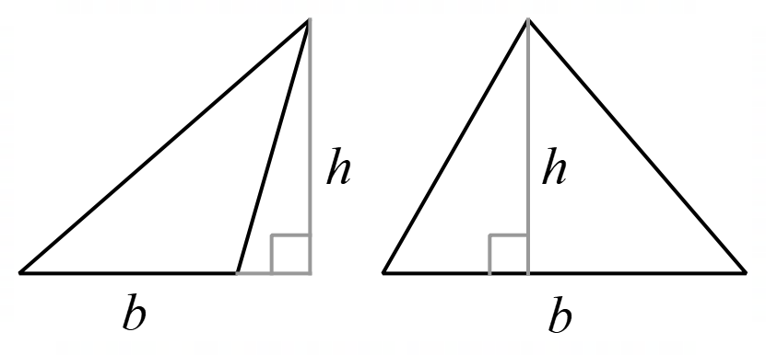 | 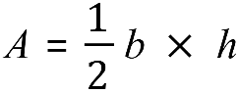 | Area = half of the length of the base multiplied by the perpendicular height
Circle
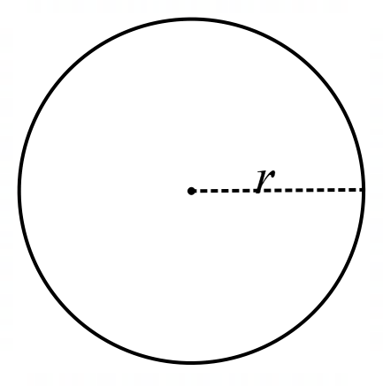 | 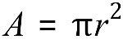 | Area = pi multiplied by the radius of the circle squared
Parallelogram
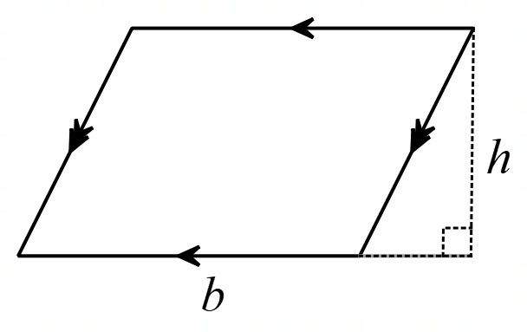 | 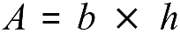 | Area = the length of the base multiplied by the perpendicular height.
Trapezium
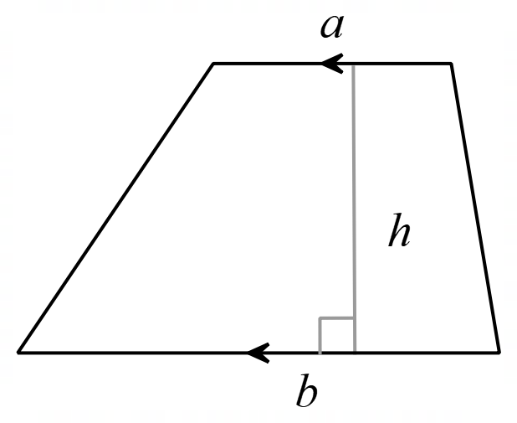 | 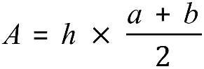 | Area = the length of the base multiplied by the perpendicular height.

